1 abra seu app no android studio

Coloque na visão de Project

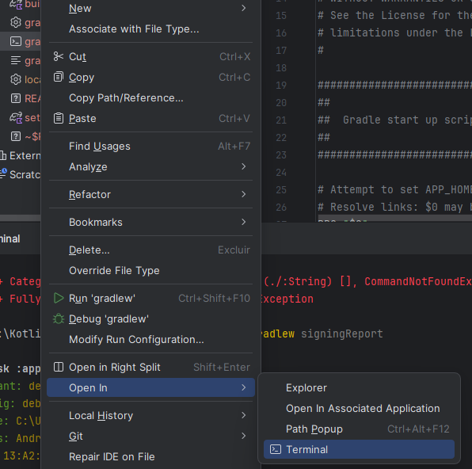

Clique em gradlew va ate terminal

Digite o código

./gradlew signingReport

Ai esta suas chaves

> Task :app:signingReport

Variant: debug

Config: debug

Store: C:\Users\allep\.android\debug.keystore

Alias: AndroidDebugKey

MD5: 13:A2:B4:0C:84:14:59:70:1A:52:9A:8E:E0:54:79:8E

SHA1: 96:AC:C6:9C:3D:8B:A9:02:C2:B7:76:F5:AF:06:CF:06:D4:E8:5E:D6

SHA-256: 85:8C:AE:04:EA:70:8E:9E:DE:12:74:E8:B8:78:10:FC:61:94:0C:D9:D2:87:8B:FF:2A:7B:E2:E2:50:C1:42:DD

Valid until: sexta-feira, 25 de setembro de 2054

----------

Variant: release

Config: null

Store: null

Alias: null

----------

Variant: debugAndroidTest

Config: debug

Store: C:\Users\allep\.android\debug.keystore

Alias: AndroidDebugKey

MD5: 13:A2:B4:0C:84:14:59:70:1A:52:9A:8E:E0:54:79:8E

SHA1: 96:AC:C6:9C:3D:8B:A9:02:C2:B7:76:F5:AF:06:CF:06:D4:E8:5E:D6

SHA-256: 85:8C:AE:04:EA:70:8E:9E:DE:12:74:E8:B8:78:10:FC:61:94:0C:D9:D2:87:8B:FF:2A:7B:E2:E2:50:C1:42:DD

Valid until: sexta-feira, 25 de setembro de 2054

----------